Week 2 Lab 02  
  
1. Write down a program in C++ that take an age of 10 students as an input from user and display the largest age of the student from an array.   
  
#include <iostream>

using namespace std;

int main() {

const int numStudents = 10;

int ages[numStudents];

int maxAge = 0;

cout << "Enter the ages of 10 students:" << endl;

for (int i = 0; i < numStudents; i++) {

cout << "Student " << i + 1 << ": ";

cin >> ages[i];

if (ages[i] > maxAge) {

maxAge = ages[i];

}

}

cout << "The largest age is: " << maxAge << endl;

return 0;

}

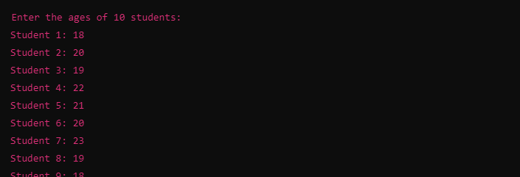



1. Write down a program in C++ that take an input data from user in three different arrays and then add the arrays and store them in another array. (Through Dynamic array concept).  
     
     
   #include <iostream>
2. using namespace std;
3. int main() {
4. int size;
5. cout << "Enter the size of the arrays: ";
6. cin >> size;
7. int\* array1 = new int[size];
8. int\* array2 = new int[size];
9. int\* array3 = new int[size];
10. int\* sumArray = new int[size]; // This will store the sum of the arrays
11. cout << "Enter elements for the first array:" << endl;
12. for (int i = 0; i < size; i++) {
13. cout << "Element " << i + 1 << ": ";
14. cin >> array1[i];
15. }
16. cout << "Enter elements for the second array:" << endl;
17. for (int i = 0; i < size; i++) {
18. cout << "Element " << i + 1 << ": ";
19. cin >> array2[i];
20. }
21. cout << "Enter elements for the third array:" << endl;
22. for (int i = 0; i < size; i++) {
23. cout << "Element " << i + 1 << ": ";
24. cin >> array3[i];
25. }
26. // Add the arrays element-wise and store in sumArray
27. for (int i = 0; i < size; i++) {
28. sumArray[i] = array1[i] + array2[i] + array3[i];
29. }
30. cout << "The sum of the arrays is:" << endl;
31. for (int i = 0; i < size; i++) {
32. cout << "Element " << i + 1 << ": " << sumArray[i] << endl;
33. }
34. delete[] array1;
35. delete[] array2;
36. delete[] array3;
37. delete[] sumArray;
38. return 0;

}  
  
  
  
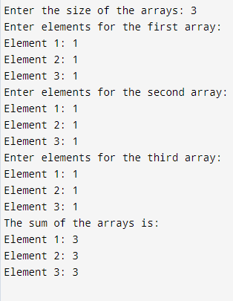  
  
  
3.Write a program for linear search using the concept of dynamic array (Note: Program should handle the situation if item is not in the list).  
  
  
 #include <iostream>

* using namespace std;
* int main() {
* int size, item, index = -1;
* cout << "Enter the number of elements in the array: ";
* cin >> size;
* int arr = new int[size];
* cout << "Enter the elements of the array: " << endl;
* for (int i = 0; i < size; ++i) {
* cin >> arr[i];
* }
* cout << "Enter the item to search: ";
* cin >> item;
* for (int i = 0; i < size; ++i) {
* if (arr[i] == item) {
* index = i;
* break; // Exit loop when item is found
* }
* }
* if (index != -1) {
* cout << "Item found at index " << index << "." << endl;
* } else {
* cout << "Item not found in the array." << endl;
* }
* delete[ ] arr;
* return 0;
* }